### Creation of a Redshift Cluster

**Screenshots of the configuration of the Redshift cluster that you have created:**

1. Creating subnet group

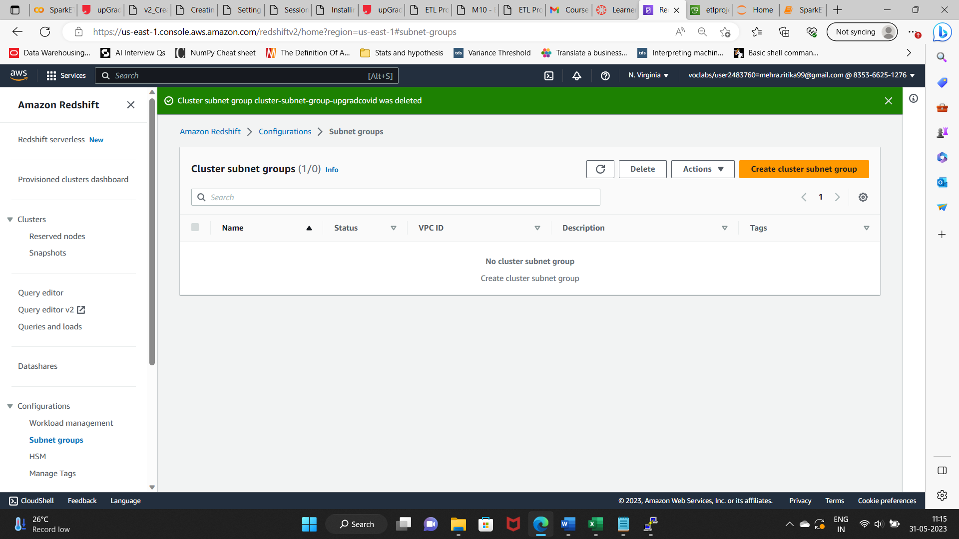

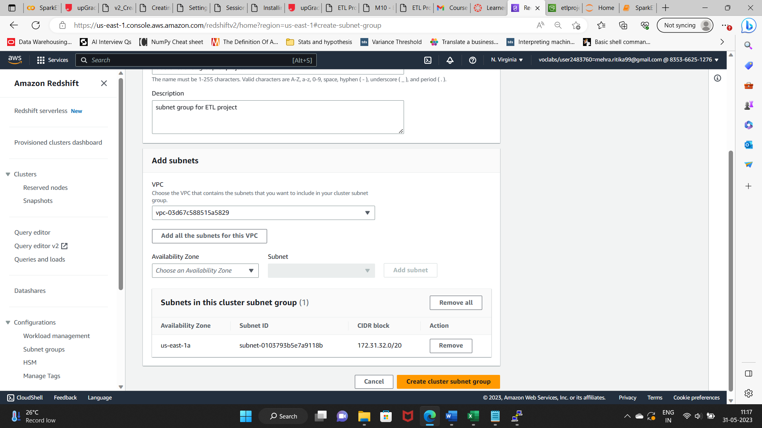

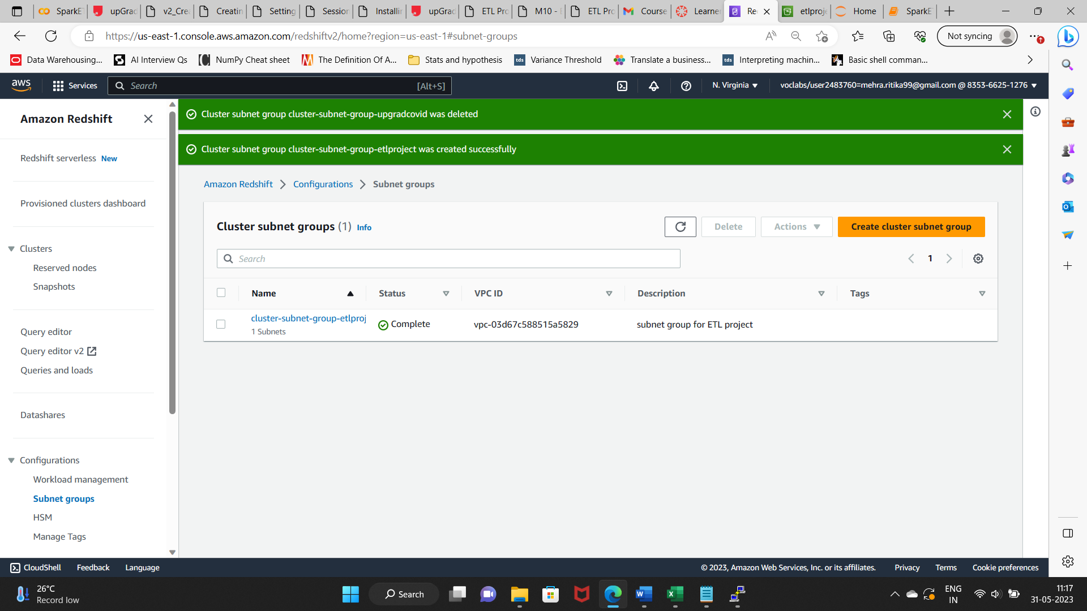

Creating Cluster

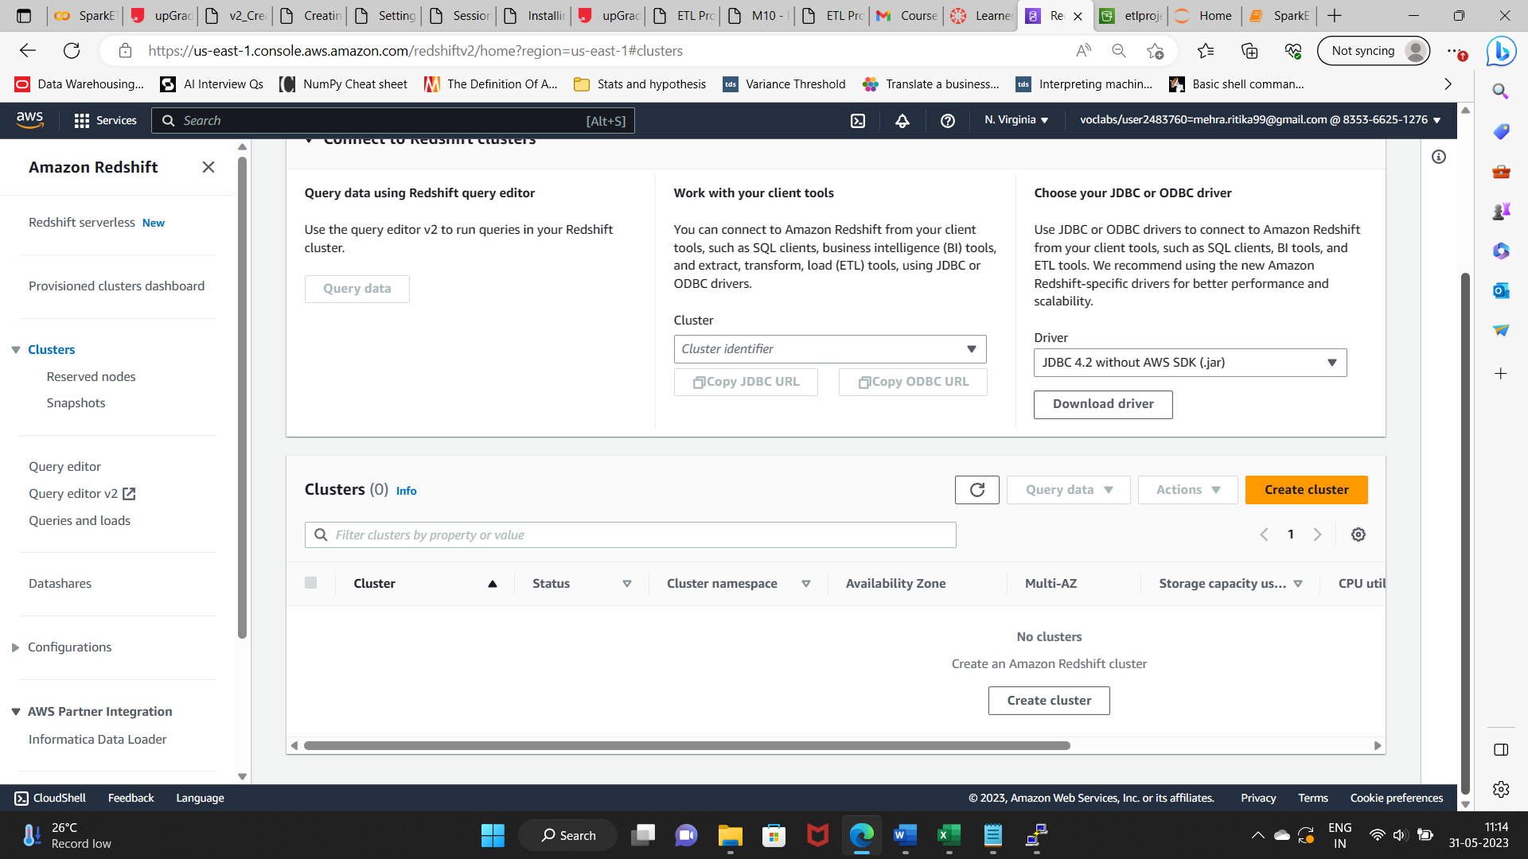

Node type: dc2.large, Number of Node: 2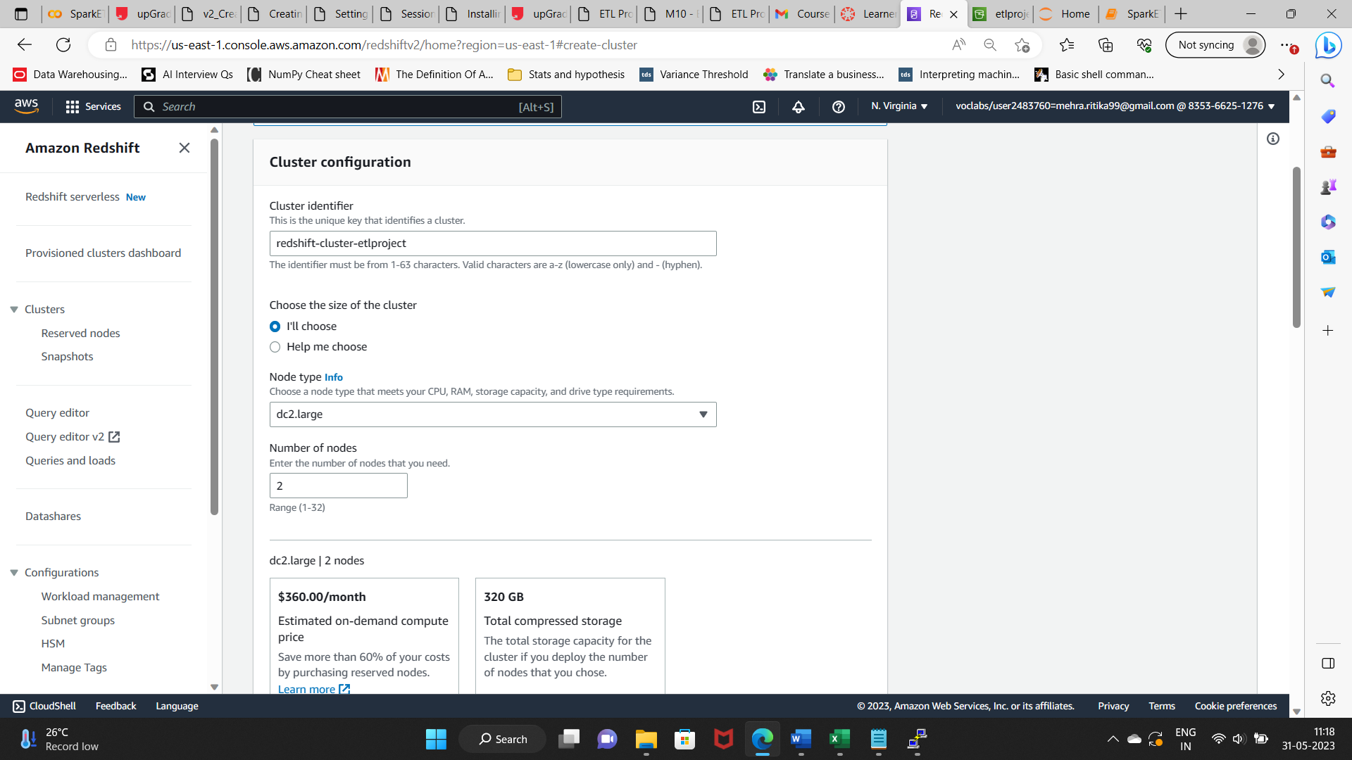

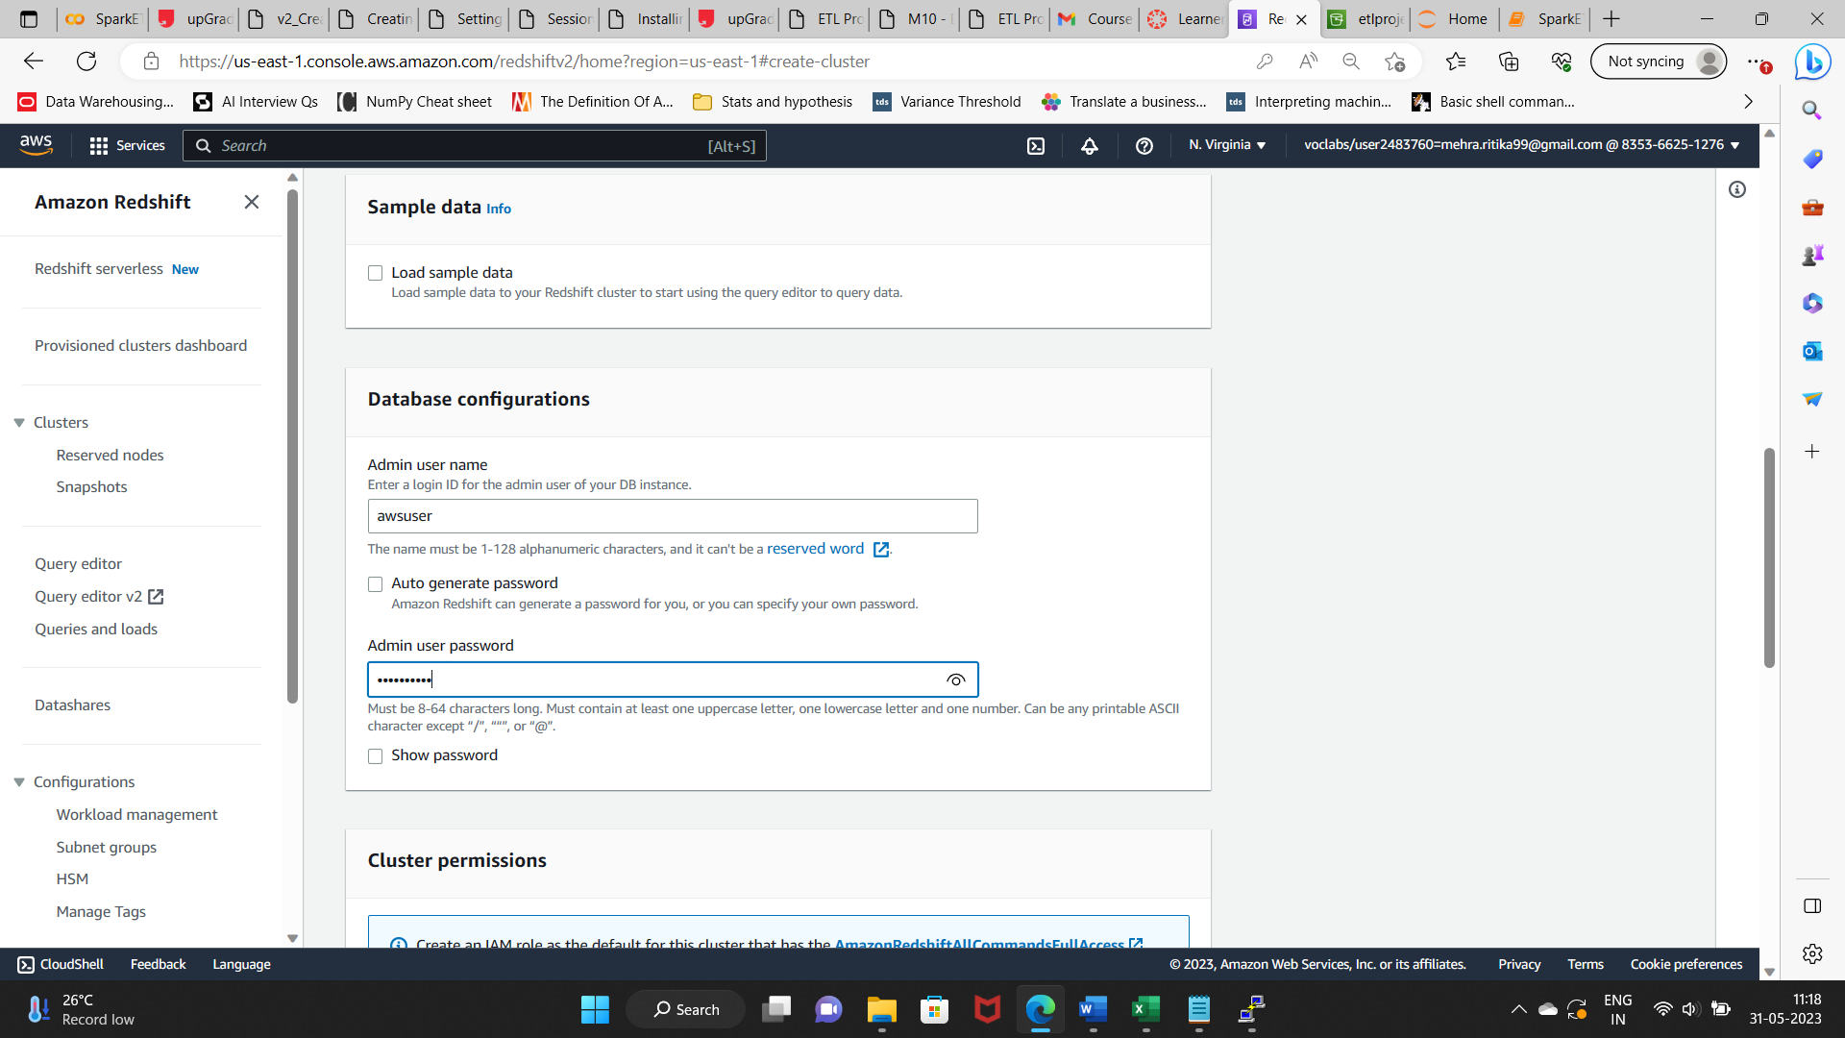

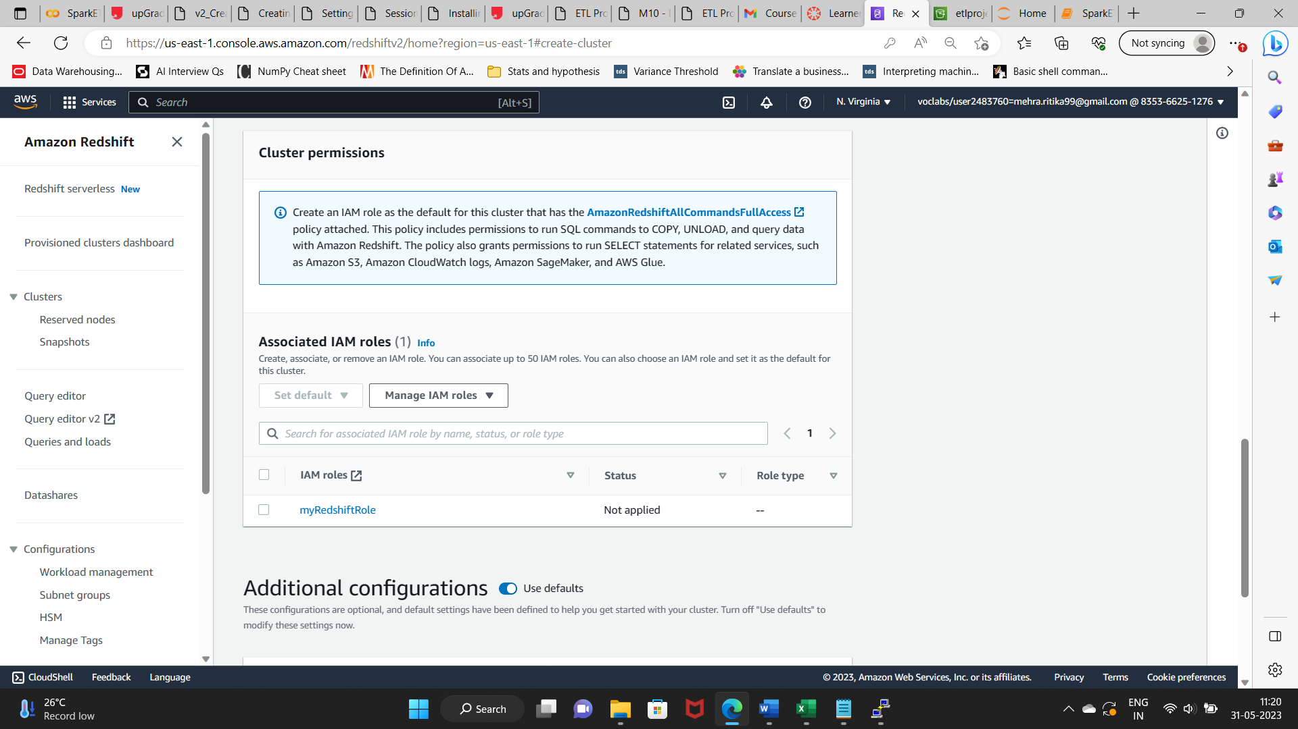

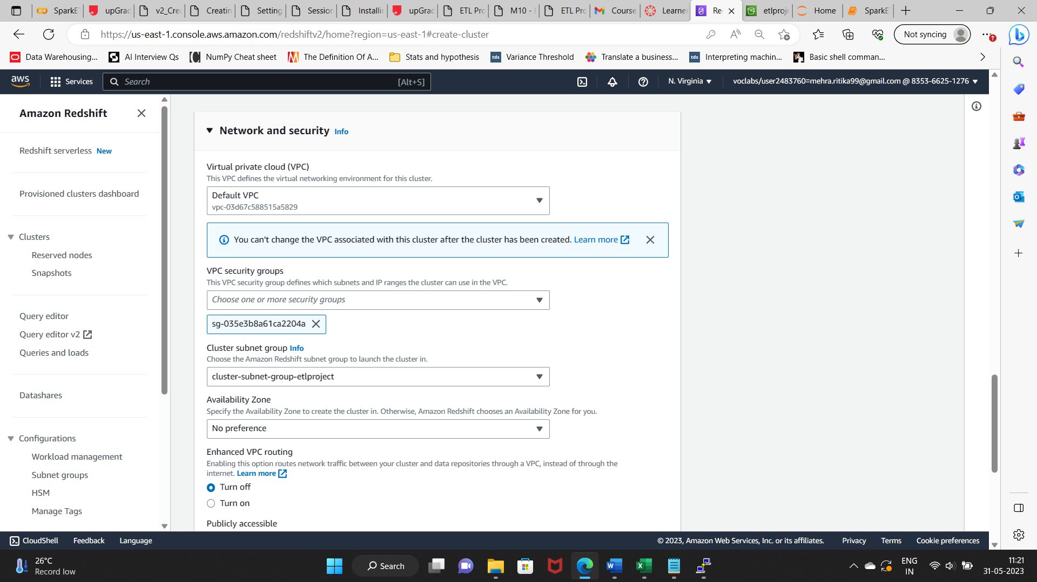

Changed default database port to 1150 for better security.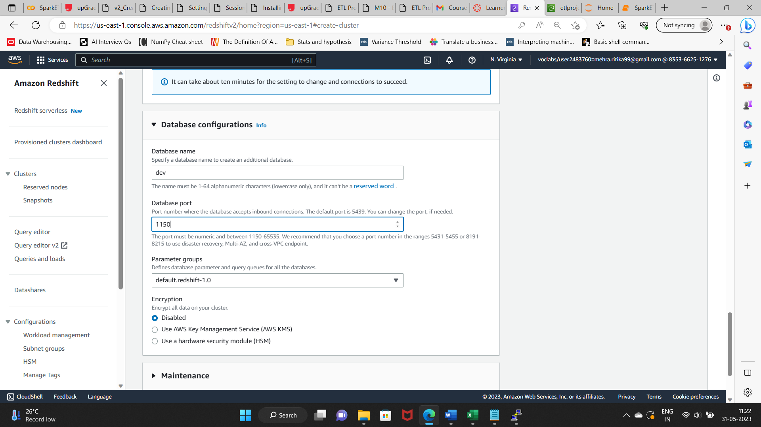

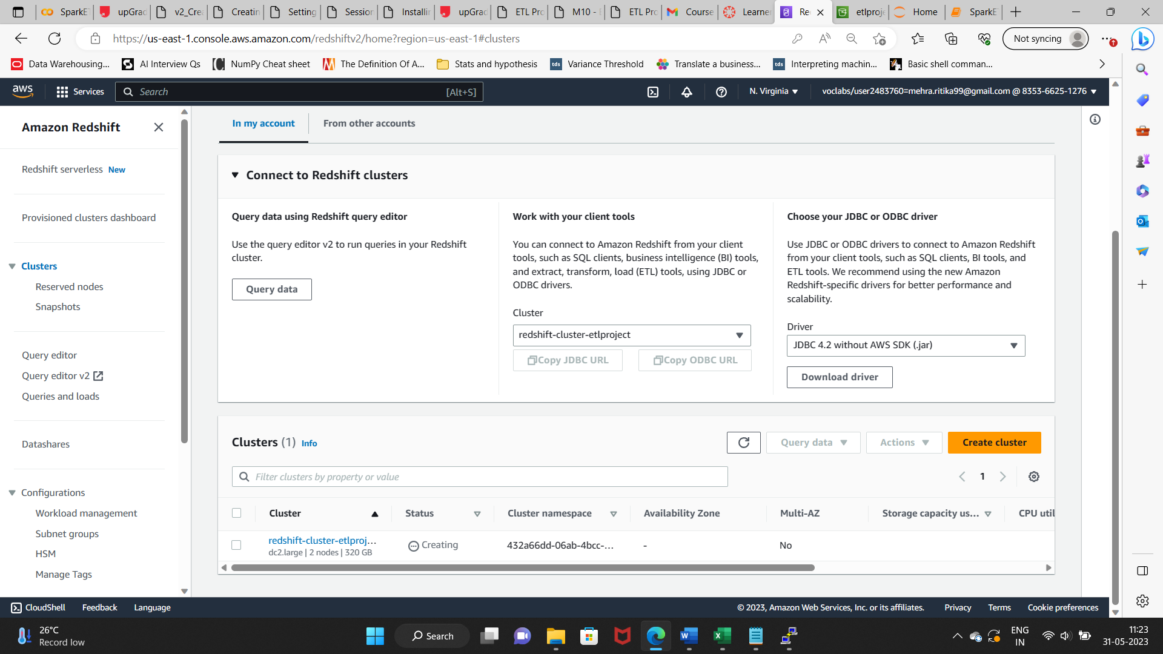

### Setting up a database in the Redshift cluster and running queries to create the dimension and fact tables

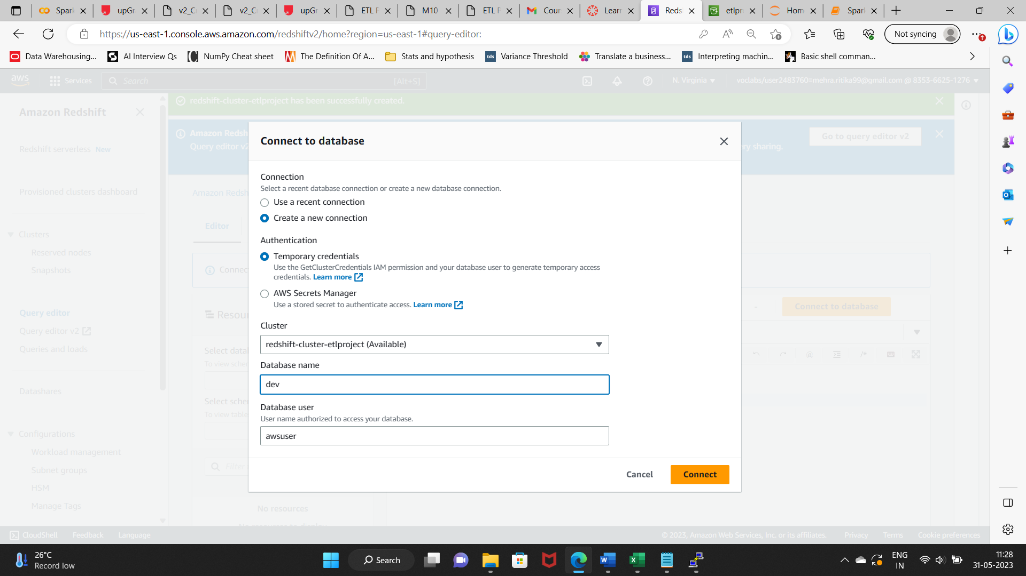

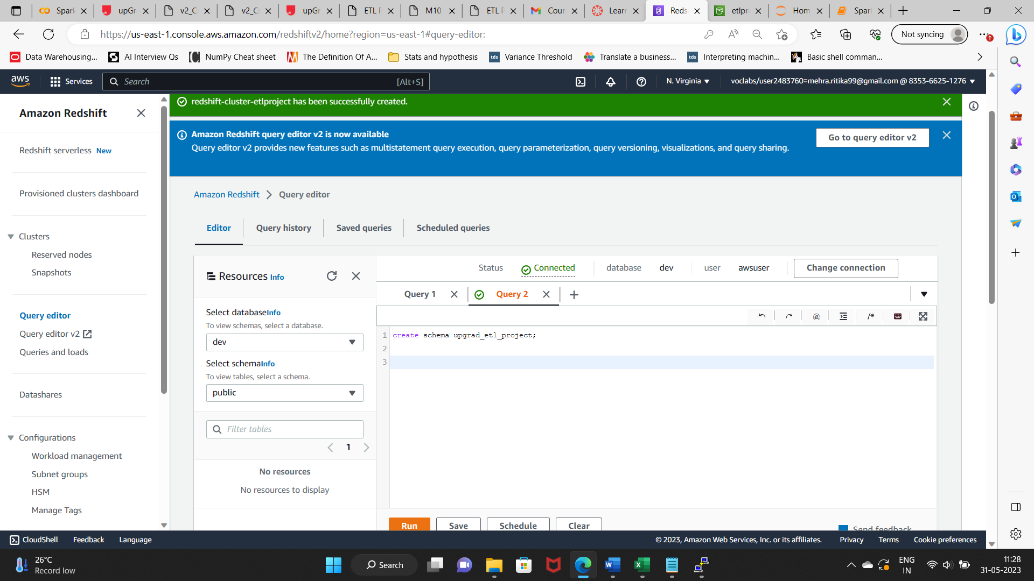

**Queries to create the various dimension and fact tables with appropriate primary and foreign keys:**

Schema Creation:

create schema upgrad_etl_proj;

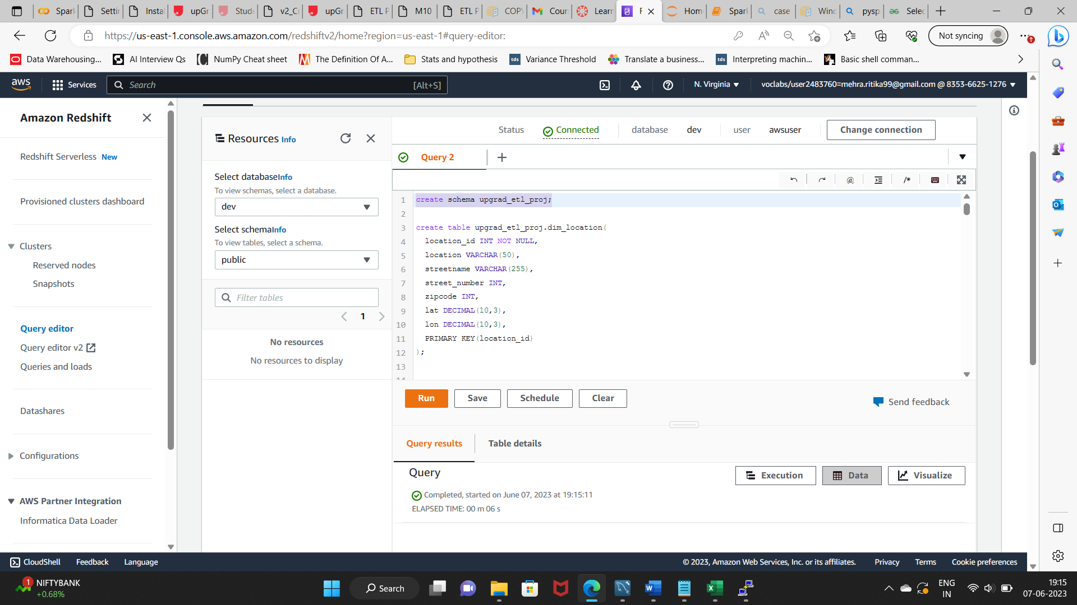

Dimension tables creation:

1. Location Dimension:

create table upgrad_etl_proj.dim_location(

location_id INT NOT NULL,

location VARCHAR(50),

streetname VARCHAR(255),

street_number INT,

zipcode INT,

lat DECIMAL(10,3),

lon DECIMAL(10,3),

PRIMARY KEY(location_id)

);

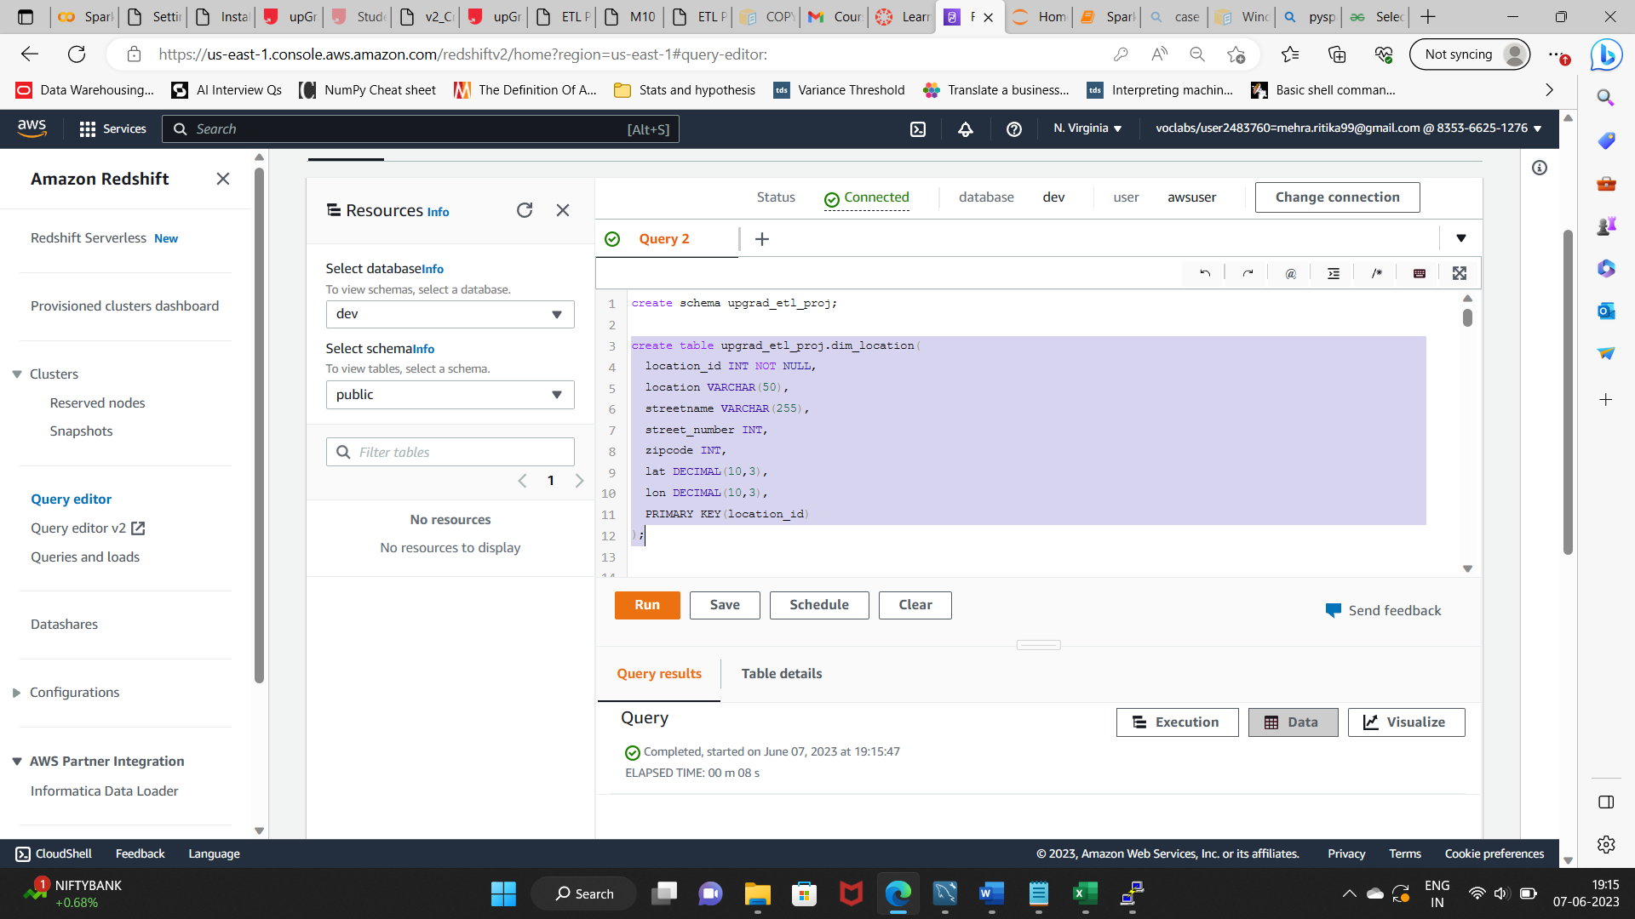

1. ATM Dimension

create table upgrad_etl_proj.dim_atm(

atm_id INT,

atm_number VARCHAR(20),

atm_manufacturer VARCHAR(50),

atm_location_id INT,

PRIMARY KEY (atm_id),

FOREIGN KEY (atm_location_id) REFERENCES upgrad_etl_proj.DIM_LOCATION (location_id)

);

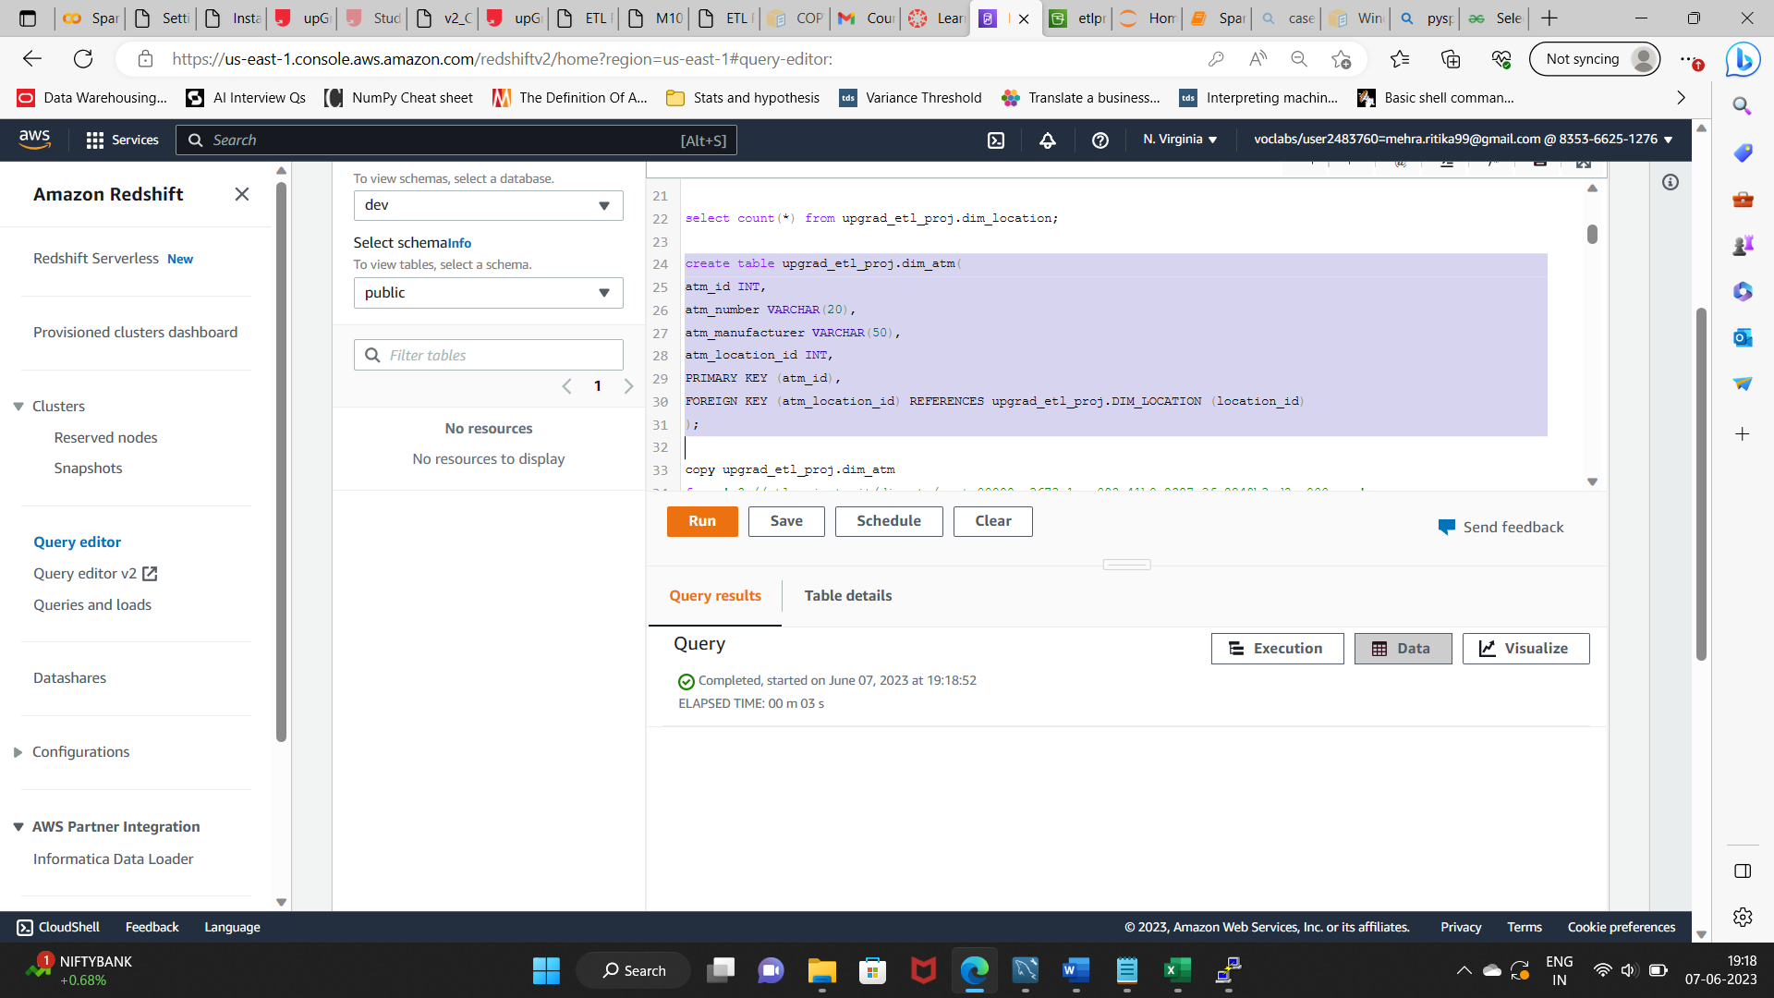

1. Date Dimension

create table upgrad_etl_proj.dim_date(

date_id INT,

full_date_time TIMESTAMP,

year INT,

month VARCHAR(20),

day INT,

hour INT,

weekday VARCHAR(20),

PRIMARY KEY (date_id)

);

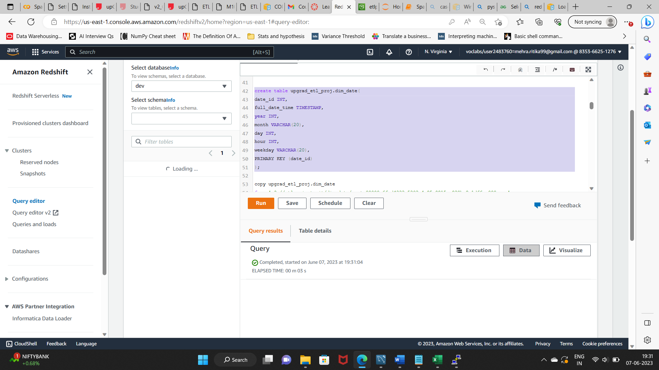

1. Card Type Dimension

create table upgrad_etl_proj.dim_card_type(

card_type_id INT,

card_type VARCHAR(30),

PRIMARY KEY (card_type_id)

);

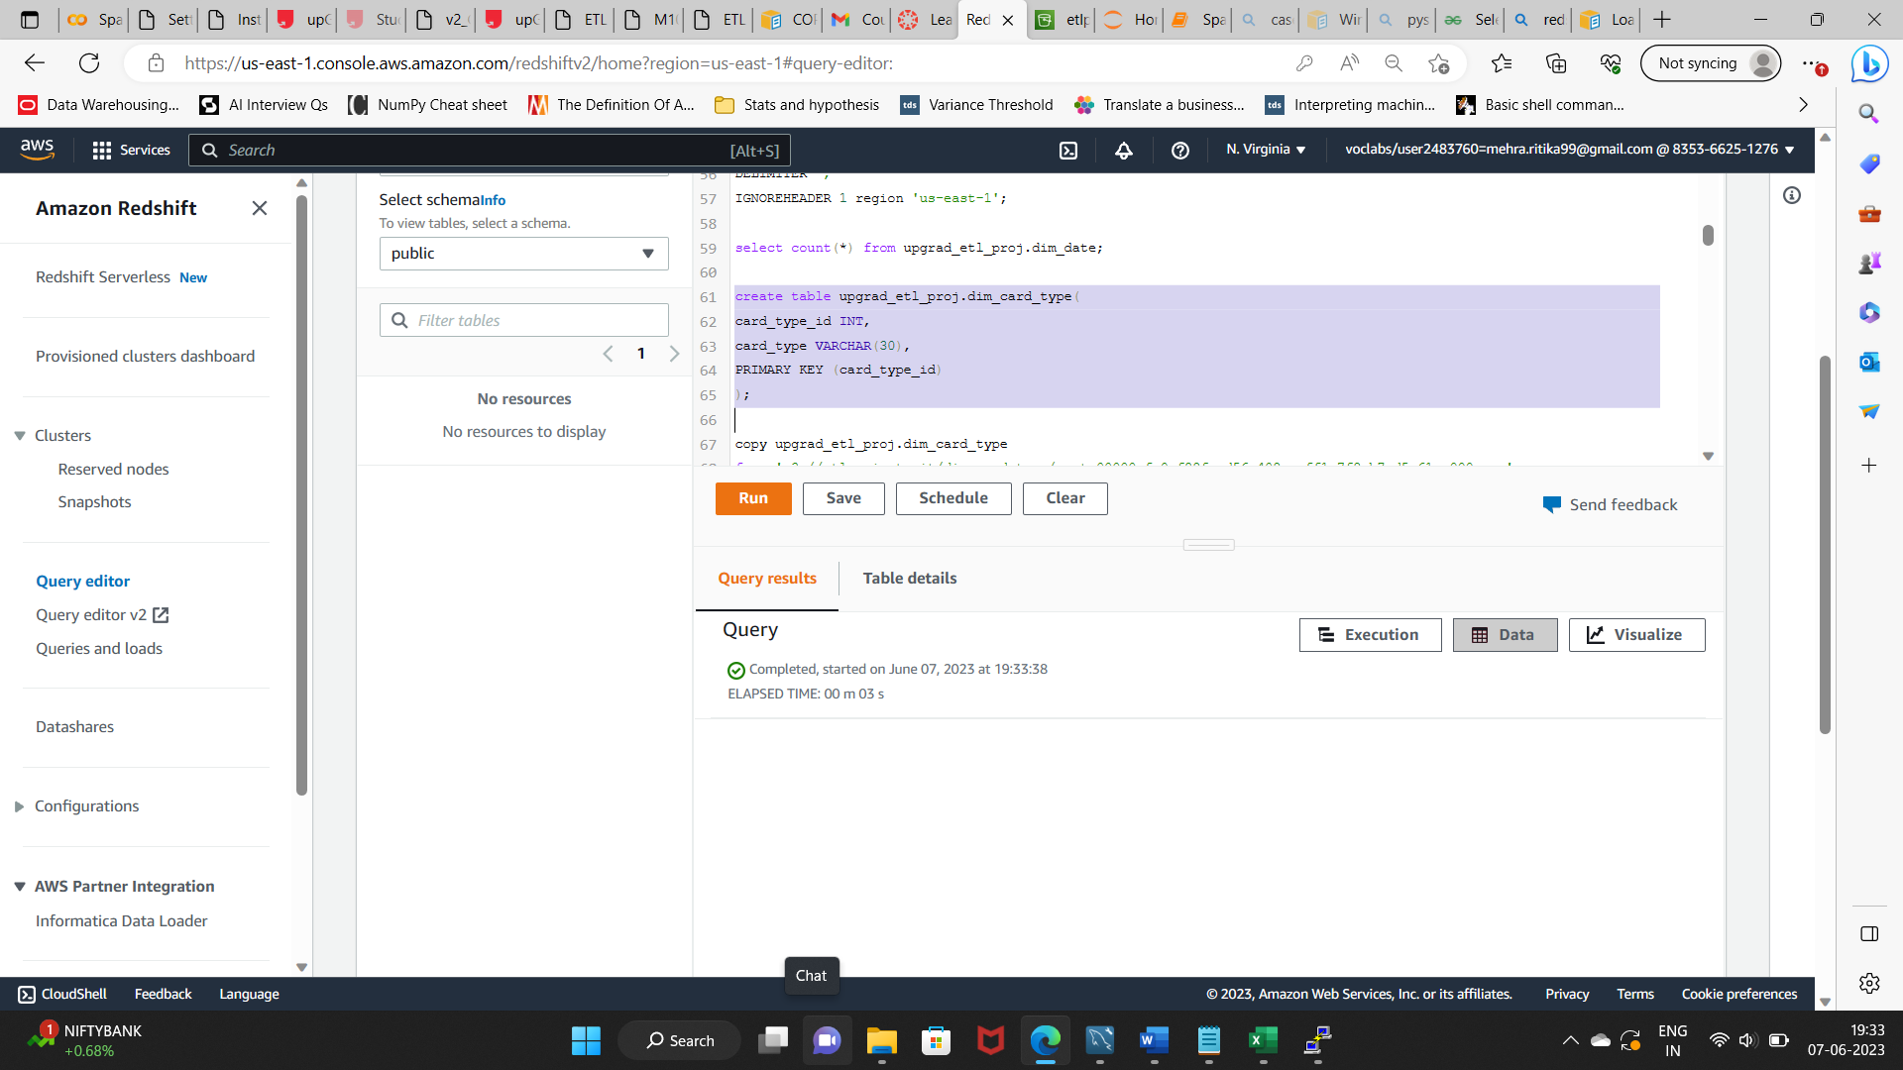

Fact Table Creation:

create table upgrad_etl_proj.fact_atm_trans(

trans_id BIGINT,

atm_id INT,

weather_loc_id INT,

date_id INT,

card_type_id INT,

atm_status VARCHAR(20),

currency VARCHAR(10),

service VARCHAR(20),

transaction_amount INT,

message_code VARCHAR(255),

message_text VARCHAR(255),

rain_3h DECIMAL(10,3),

clouds_all DECIMAL(10,3),

weather_id INT,

weather_main VARCHAR(50),

weather_description VARCHAR(255),

PRIMARY KEY (trans_id),

FOREIGN KEY (weather_loc_id) REFERENCES upgrad_etl_proj.DIM_LOCATION (location_id),

FOREIGN KEY (atm_id) REFERENCES upgrad_etl_proj.DIM_ATM (atm_id),

FOREIGN KEY (date_id) REFERENCES upgrad_etl_proj.DIM_DATE (date_id),

FOREIGN KEY (card_type_id) REFERENCES upgrad_etl_proj.DIM_CARD_TYPE (card_type_id)

);

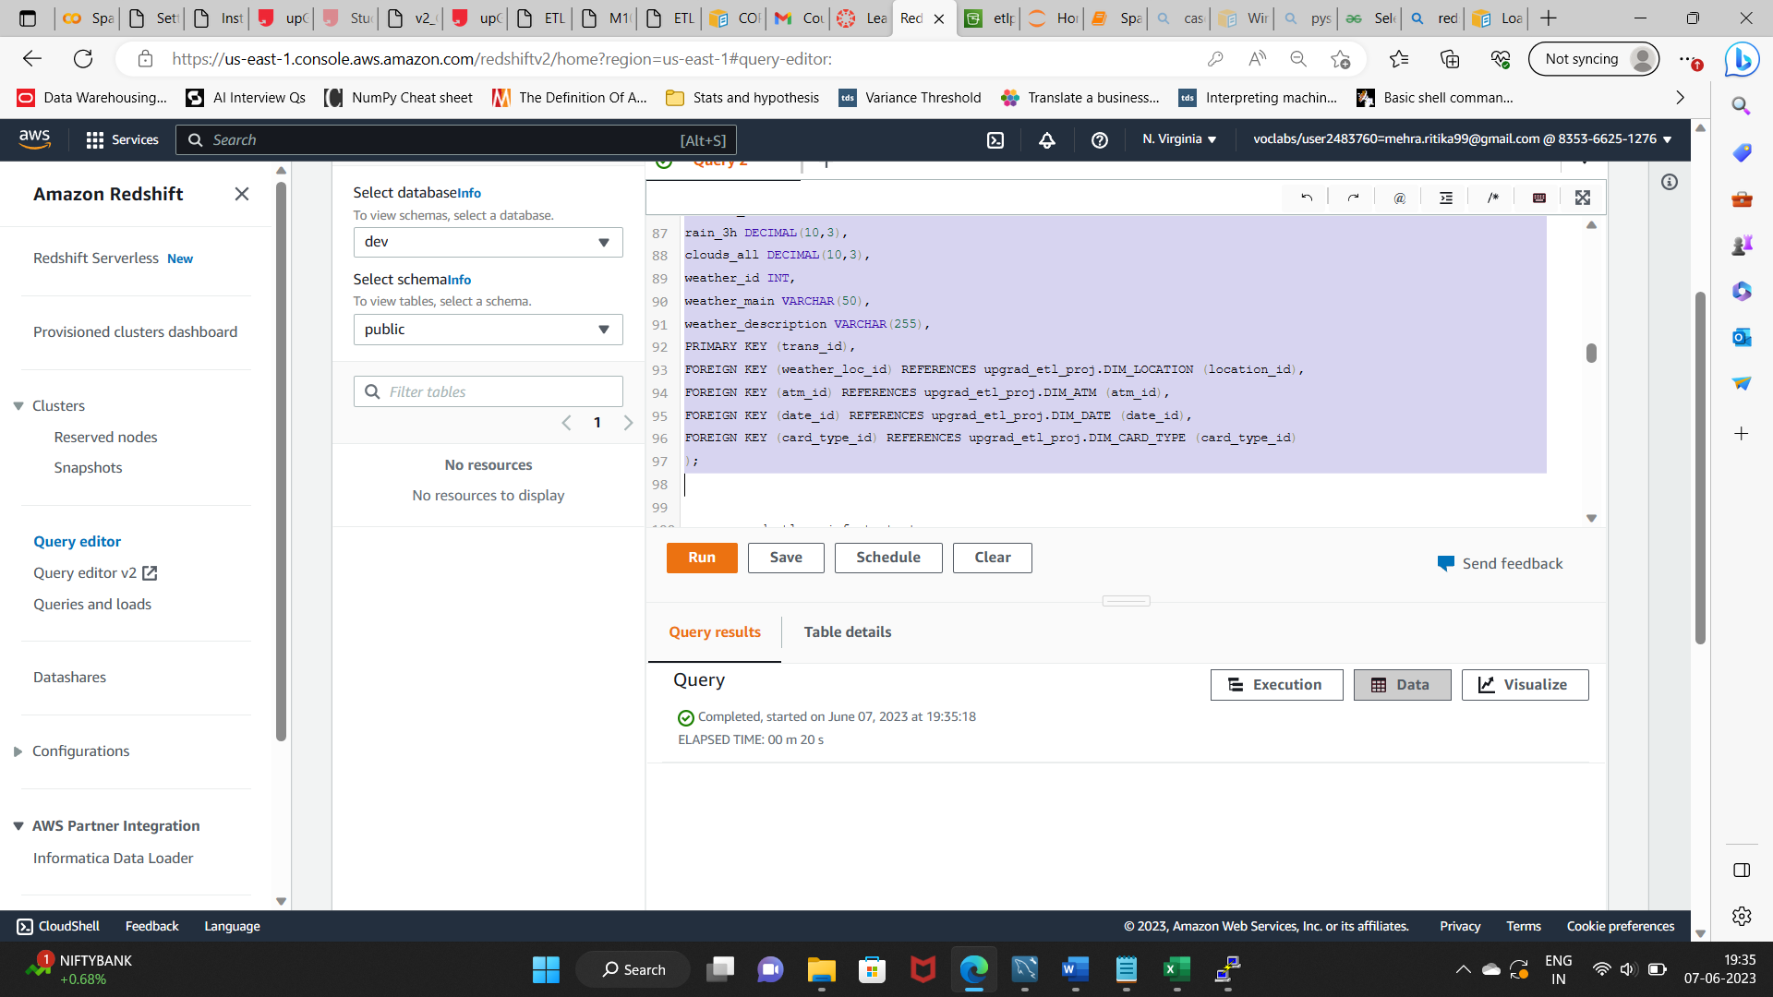

### Loading data into a Redshift cluster from Amazon S3 bucket

**Queries to copy the data from S3 buckets to the Redshift cluster in the appropriate tables**

**Note: All copy commands have s3 location path to indicate file starting with part as the file name changes for each fresh run.**

1. **Loading data to location dimension table.**

copy upgrad_etl_proj.dim_location

from 's3://etlproject-rit/dim_location/part'

iam_role 'arn:aws:iam::835366251276:role/myRedshiftRole'

DELIMITER ','

IGNOREHEADER 1 region 'us-east-1';

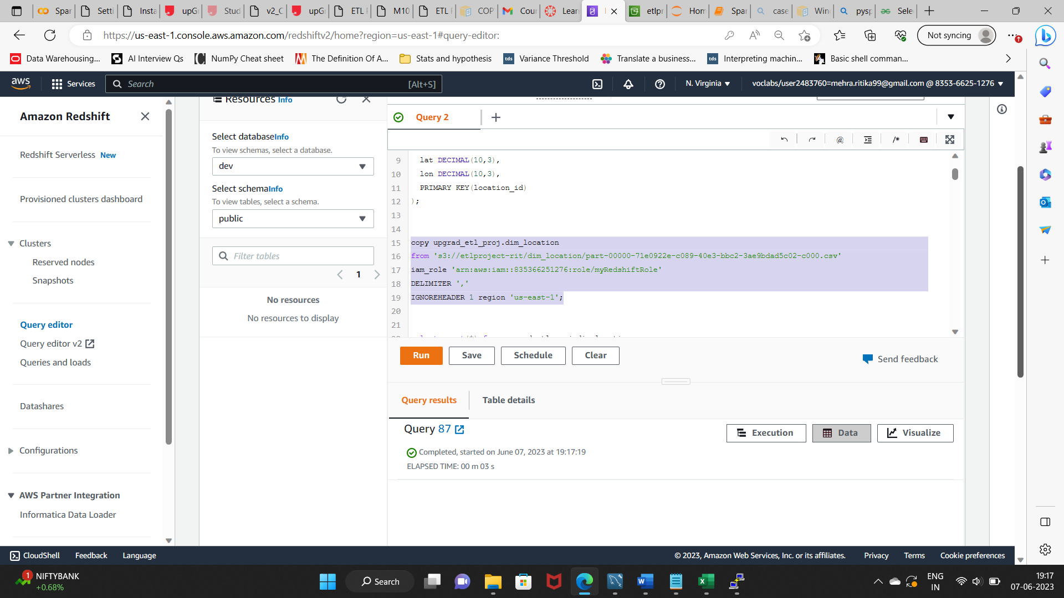

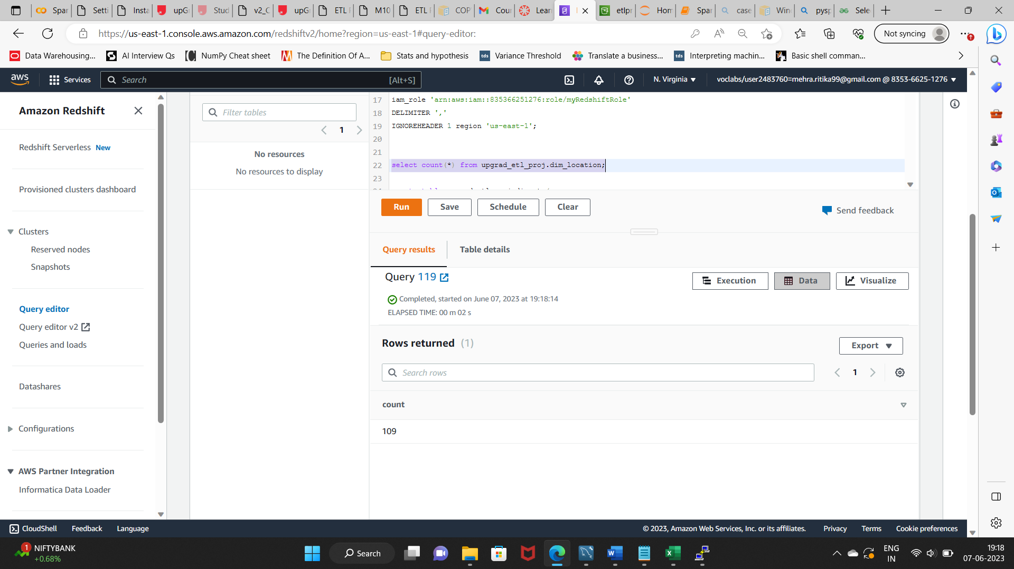

1. **Loading data to atm dimension table.**

copy upgrad_etl_proj.dim_atm

from 's3://etlproject-rit/dim_atm/part'

iam_role 'arn:aws:iam::835366251276:role/myRedshiftRole'

DELIMITER ','

IGNOREHEADER 1 region 'us-east-1';

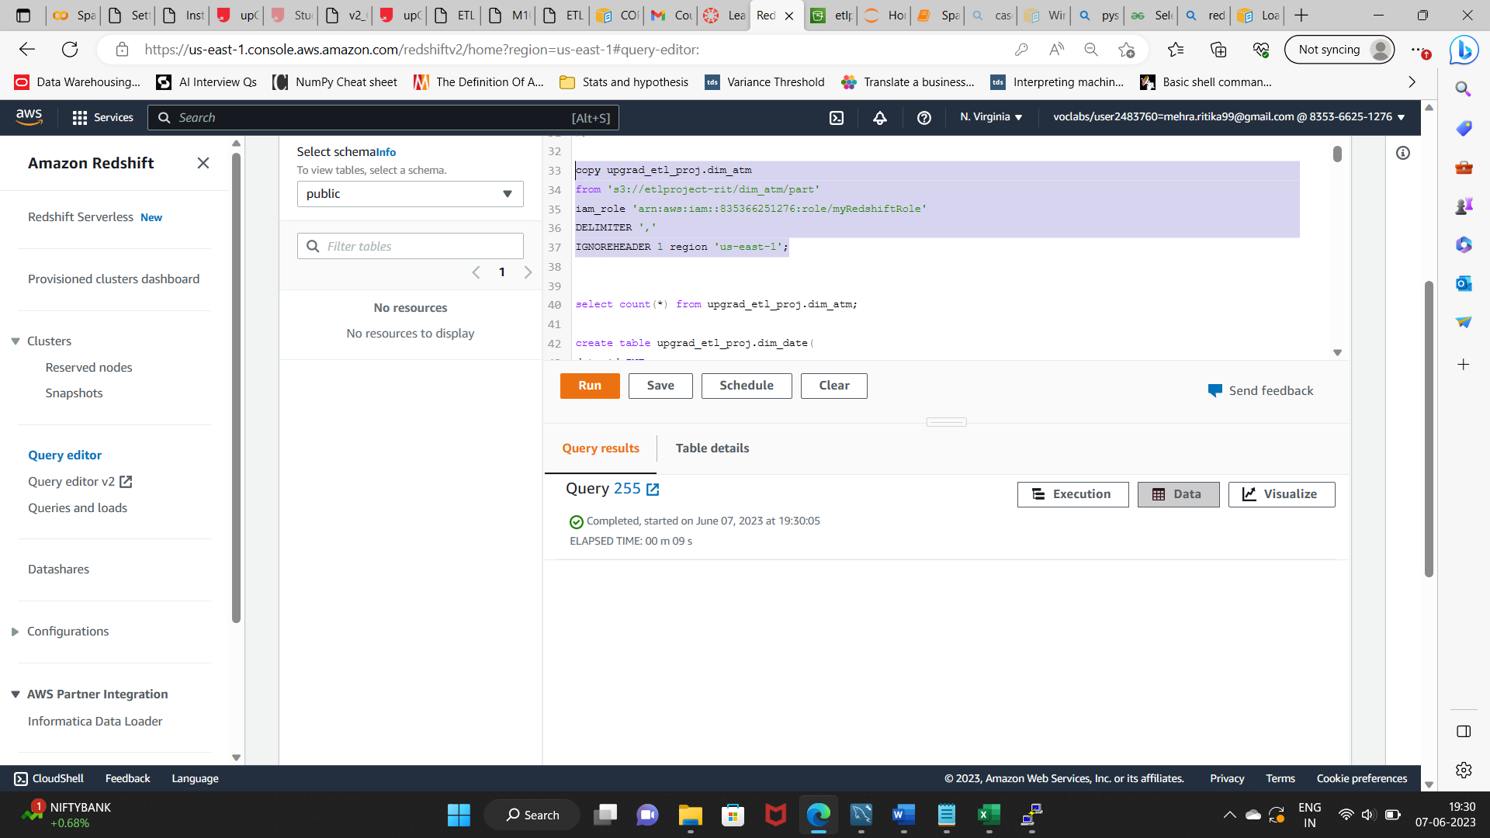

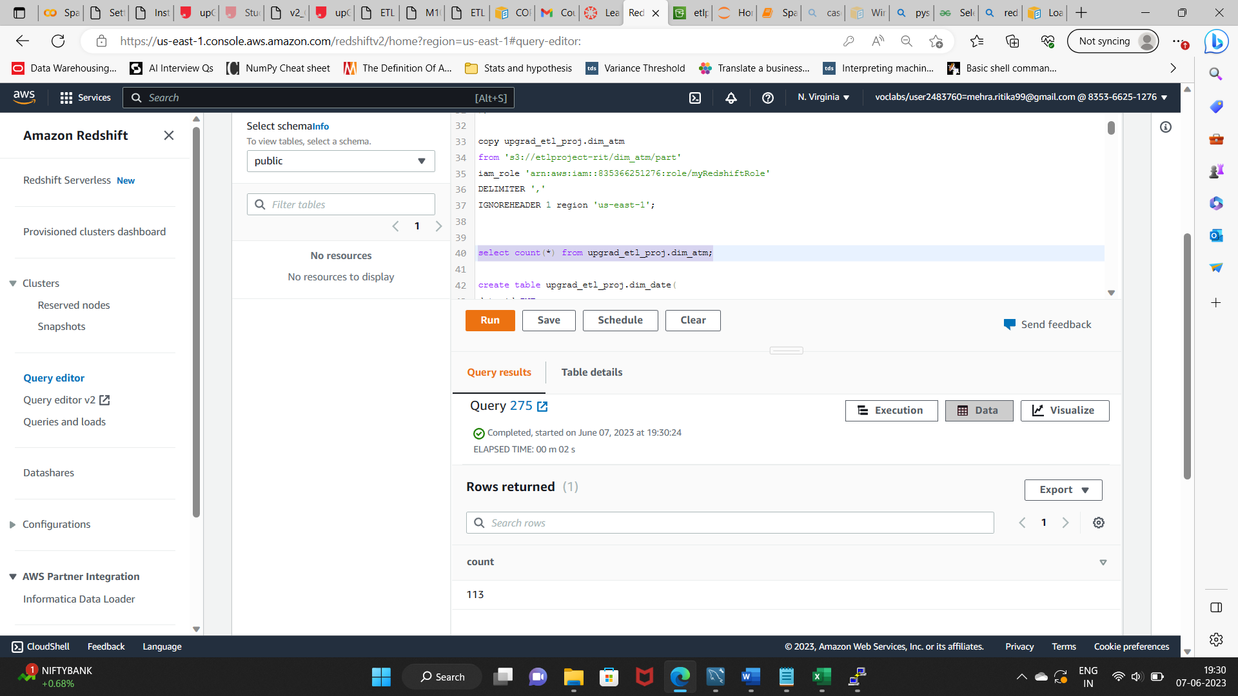

1. **Loading data to date dimension table.**

copy upgrad_etl_proj.dim_date

from 's3://etlproject-rit/dim_date/part'

iam_role 'arn:aws:iam::835366251276:role/myRedshiftRole'

DELIMITER ','

IGNOREHEADER 1 region 'us-east-1';

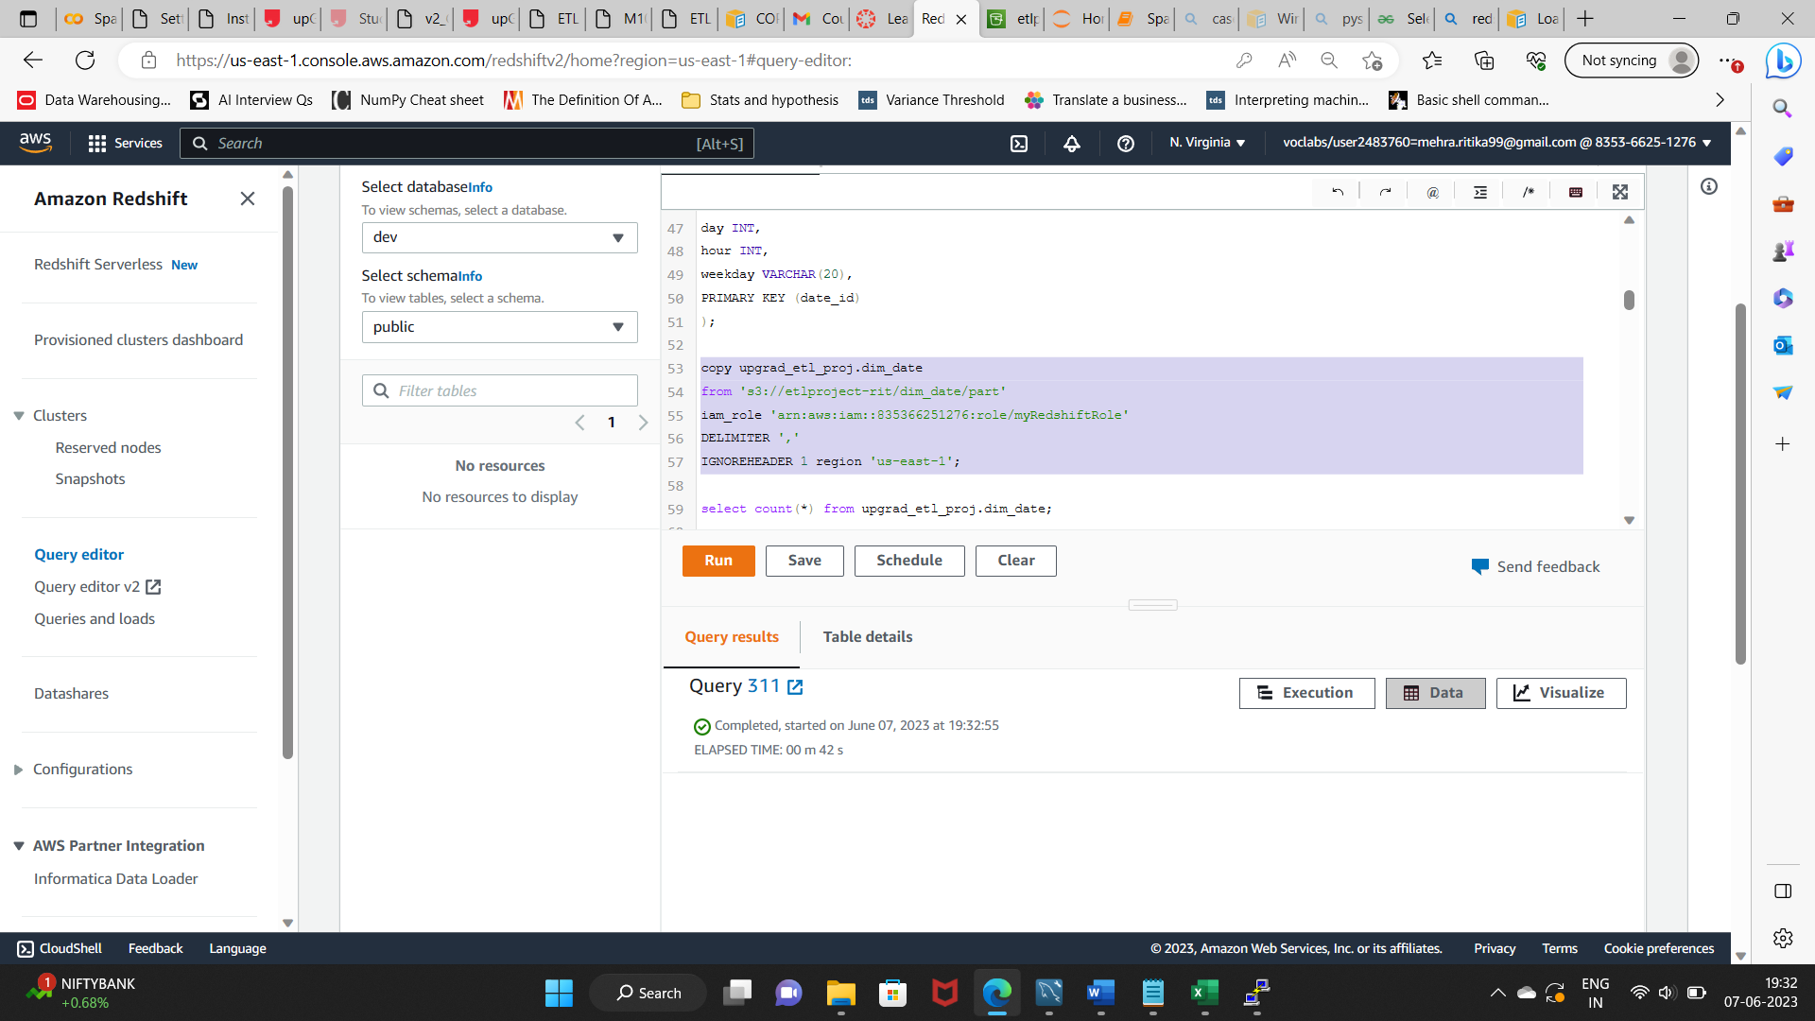

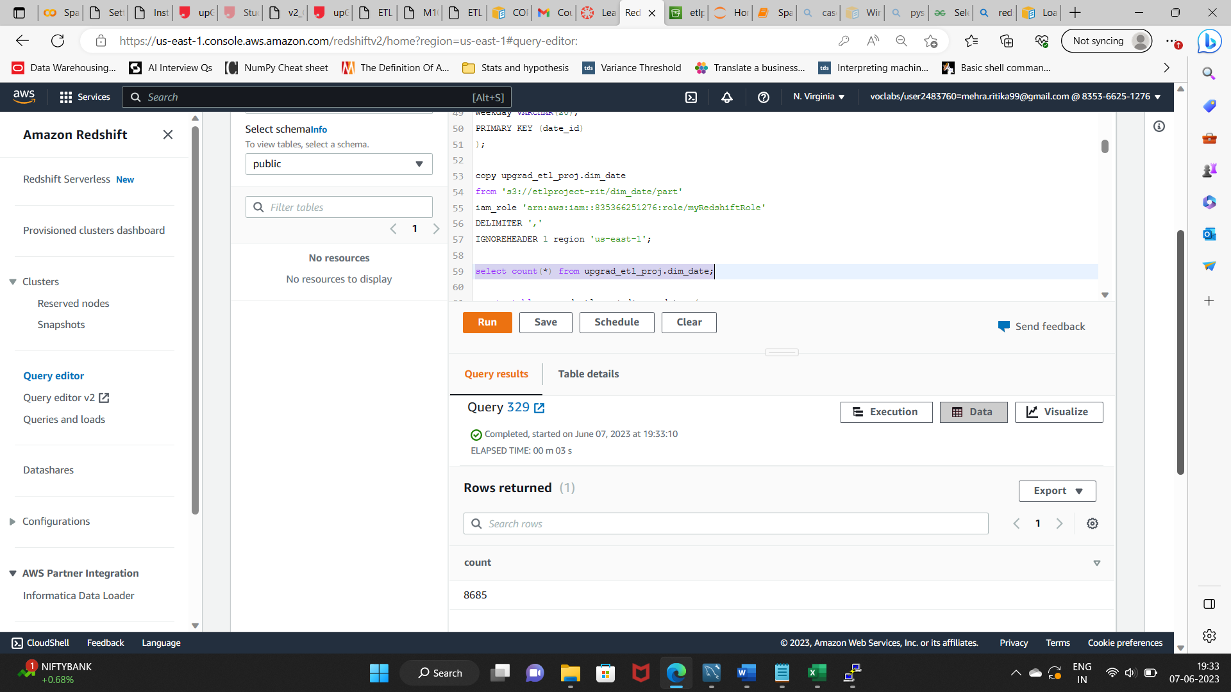

1. **Loading data to card type dimension table.**

copy upgrad_etl_proj.dim_card_type

from 's3://etlproject-rit/dim_card_type/part'

iam_role 'arn:aws:iam::835366251276:role/myRedshiftRole'

DELIMITER ','

IGNOREHEADER 1 region 'us-east-1';

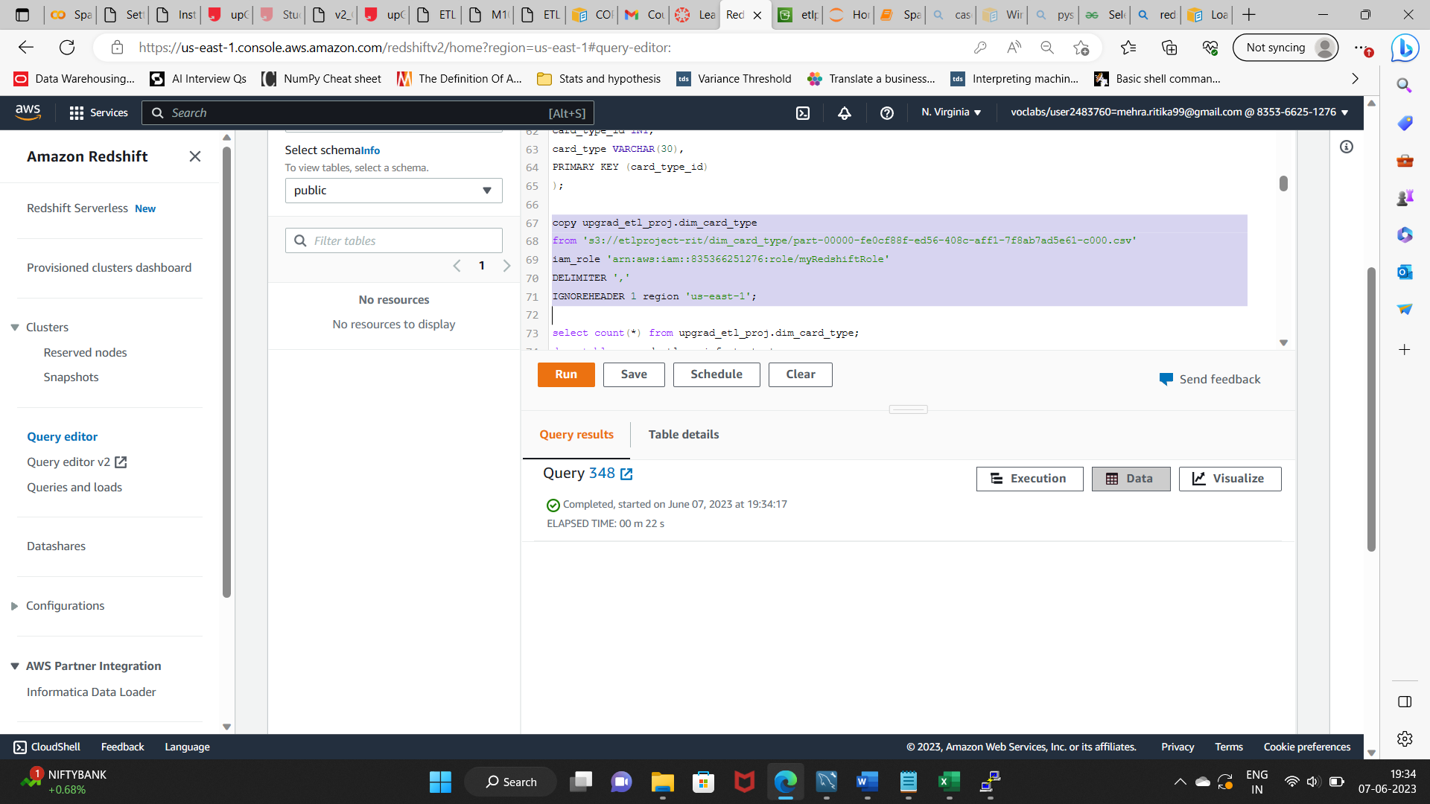

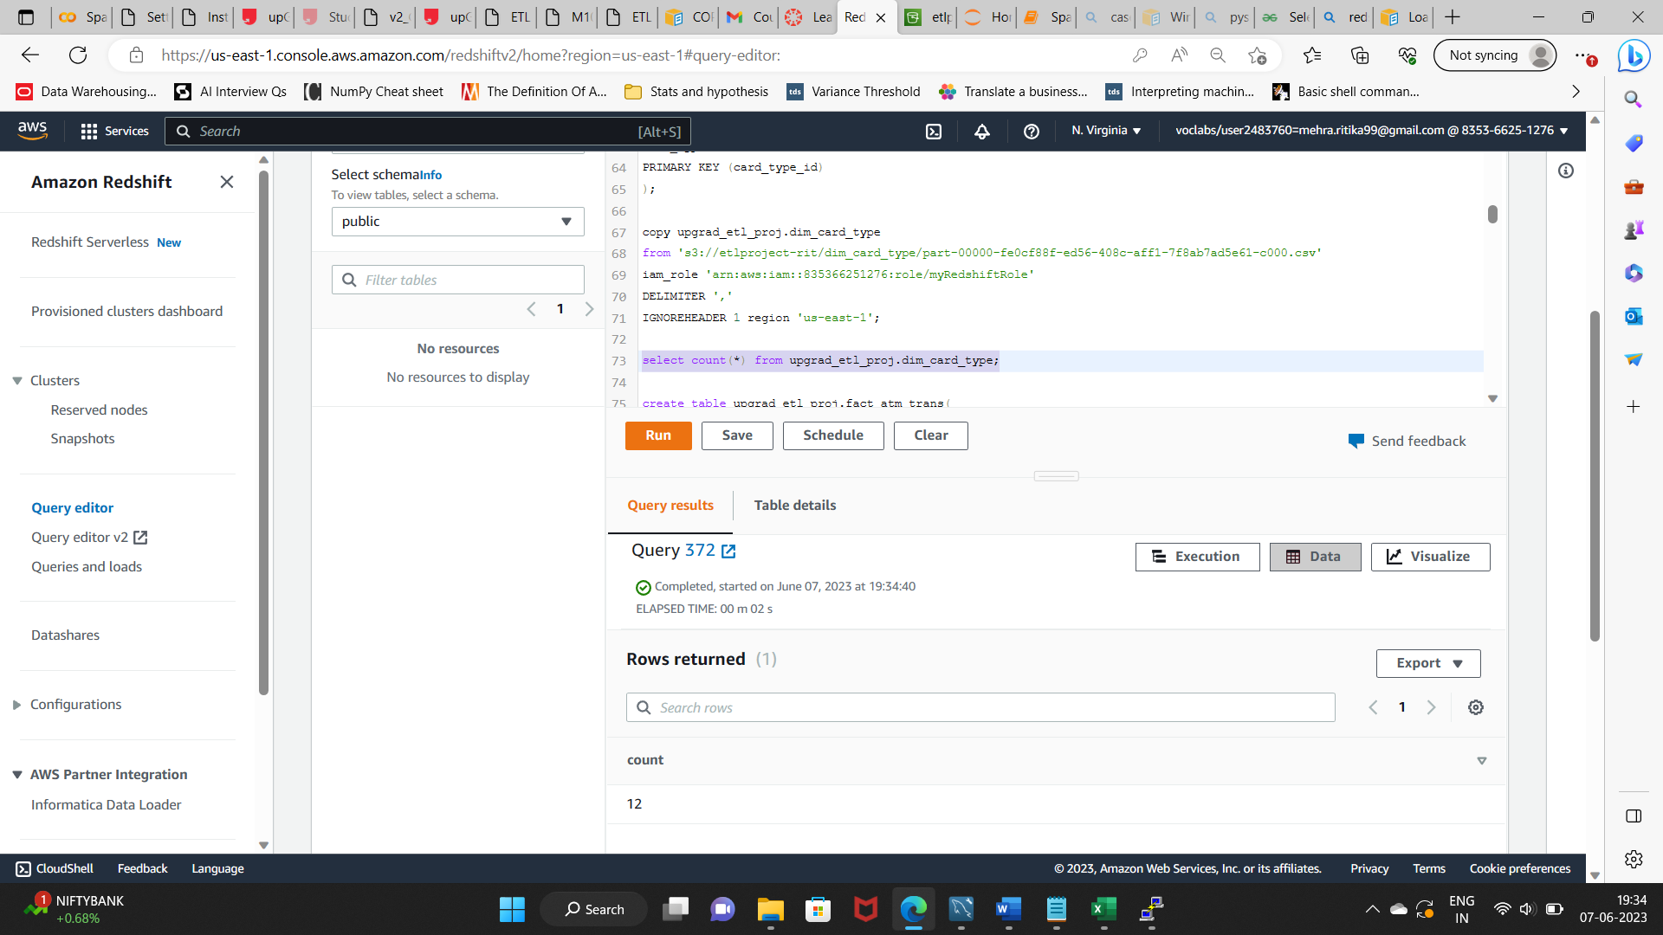

1. **Loading data to fact table.**

copy upgrad_etl_proj.fact_atm_trans

from 's3://etlproject-rit/fact_atm_trans/part'

iam_role 'arn:aws:iam::835366251276:role/myRedshiftRole'

IGNOREHEADER 1 region 'us-east-1'

csv;

